Automation Setup

1)Install VS Code from <https://code.visualstudio.com/download>

2)Install Node.js from <https://nodejs.org/en/download> While installing make sure to select npm package manager

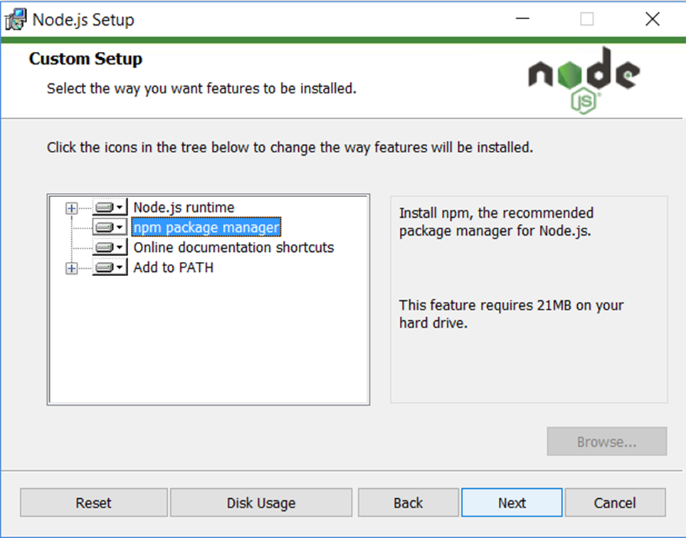

3)Install GitBash from <https://git-scm.com/download/win>

4)Install Java(JDK) from <https://www.oracle.com/in/java/technologies/downloads/>

5)Install Webdriver io using “npm init wdio@latest”

6)Install Typescript from <https://code.visualstudio.com/docs/typescript/typescript-compiling>

7)Navigate Automation Repo using <https://digital-it-apps.visualstudio.com/Digital-IT-Projects/_git/mobile-automation/branches>

8)Create a your Branch “features/Name”

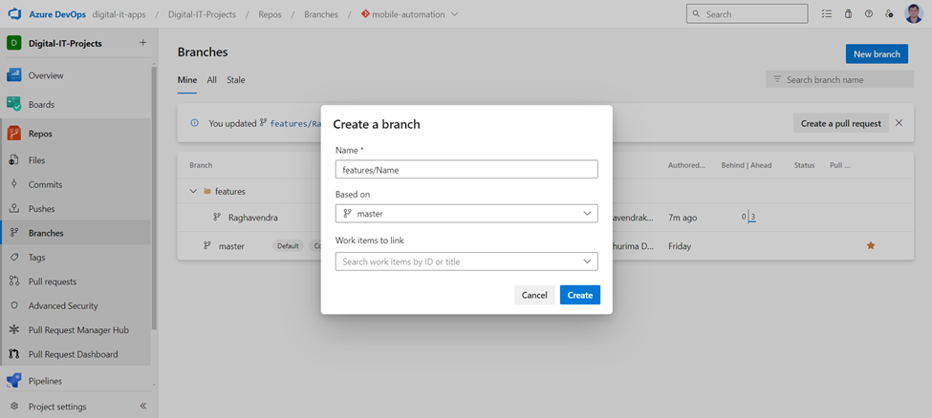

9)Navigate to master and clicking Clone and then copy the URL displayed

10)In Github Desktop paste URL in URL tab and Clone to Local

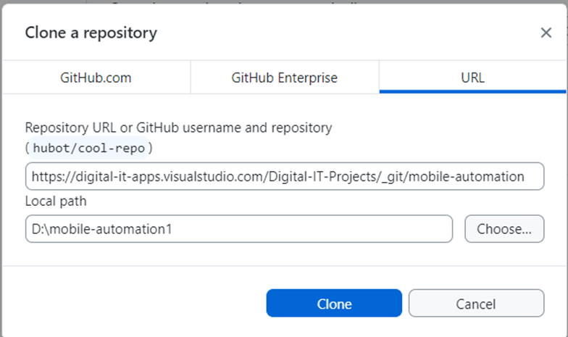

13)Open mobile-automation in VS Code and click master at Bottom left corner and select your branch

14) **Run** “npm install” to install all dependencies present in package.json

15) Copy Security token displayed in Profile section of Perfecto to cloud.config.ts

16)Update Preferred Device name in ios.info.ts and Comment all Testcases apart from one to execute in ios.config.ts

Perfecto Setup

1)Navigate to Assets and Setup and then to Private tab

2)Click Upload File button and add App version and Build number in Filename field and then copy Locator to ios.info.ts

Debugging-In package.json Click Debug above scripts section